Team 25
Client: Program for Sustainable Pavement and Research (PROSPER)
Advisers: Dr. Halil Ceylan
Nathan Conroy Software Lead
Kevin Yen Hardware Lead
Molly Hayes Meeting Scribe
Rishab Sharma Report Manager
Quade Spellman Meeting Facilitator
Issac Bries Test Engineer
sdmay18-25@iastate.edu
sdmay18-25.sd.ece.iastate.edu

Revised: 9/24/2017
Autonomous Health Monitoring of Transportation Infrastructure Using Unmanned Aerial Vehicle
Project plan

1 Introduction 3
1.1 Project statement 3
1.2 purpose 3
1.3 Goals 3
2 Deliverables 4
3 Design 5
3.1 Previous work/literature 5
3.2 Proposed System Block diagram 9
3.3 Assessment of Proposed methods 15
3.4 Validation 16
4 Project Requirements/Specifications 22
4.1 Functional 22
4.1.1 Drone 22
4.1.2 Control System 22
4.1.3 Image and Data Processing 22
4.2 Non-functional 22
4.2.1 Cost 23
4.2.3 Reliability 23
4.2.4 Reusability & Maintainability 23
4.2.5 Certifications 23
4.3 Standards 23
4.3.1 FAA 23
5 Challenges 24
6 Timeline 24
6.1 First Semester 25
6.2 Second Semester 25
7 Conclusions 27
8 References 27
9 Appendices 28

1 Introduction

1.1 Project statement
Using an Unmanned Aircraft System, or UAS, it is our responsibility to evaluate the safety and effectiveness of bridges, roads, and any other infrastructure that needs inspecting. This will be done through HD visual monitoring, Infrared Thermography, LiDAR sensors, and 3D Rendering. UAS can help contribute to a new era of civil infrastructure health monitoring.

1.2 purpose
What drives this project is the need to provide cost-effective and efficient health monitoring management of transportation infrastructure systems. One of the benefits of this project is that this is a quick way to make sure all bridges, construction work, and roads are functioning properly so that civilians are safe when they are traveling. Some other benefits include capturing traffic movement, making sure contractors are safe, and minimizing traffic accidents. The ability to collect data with an unmanned aircraft incorporates many software and hardware challenges that can help strengthen the team. The future potential of learning these skills and applying to other industries is tremendous.

1.3 Goals
What we hope to accomplish is a variety of goals that help drive our purpose and lead us to solving this project. These goals include:
1. A working UAS, aka drone, that flies for over 40 minutes.
a. Can fly in 20-30 mph wind
2. Can incorporate all the sensors and cameras that are required.
a. Have the ability to swap sensors
b. Be able to include:
i. LiDAR
ii. Thermal
iii. HD Camera
iv. Infrared
c. Be able to have the camera on gimbal
3. Should be able to take clear pictures and analysis when flying over, under, and near:
a. Bridges
b. Roads
c. Wind Turbines
4. Have a reliable communication with the control station
a. Can fly the drone with ease
b. Have the correct data analysis when measuring and collecting data
5. Meet all FAA and FCC requirements.

2 Deliverables
These tie in with the goals. What deliverables are necessary to meet the goals outlined in the introduction?
Goal | Delivarable | Expected Semester
-A working UAV, aka drone, that flies for over 40 minutes.  -Can fly in 20-30 mph wind | To properly accomplish this we need to choose the correct drone option, like hexacopter, chose the correct parts to build the drone, and be able to tune all the hardware components to different situations. | Mid March - Sem 2
-Can incorporate all the sensors and cameras that are required. | Research and learn exactly what sensors and cameras are best for our particular UAS. Once that is done we have to purchase that specific LiDAR, Thermal, HD, and Infrared cameras. | Sem 1
- Have the ability to swap sensor  -Be able to have the camera on gimbal | Know how to attach and work a gimble. Have the hardware team research and learn which combinations of sensors and cameras can be put on our UAS. Then we build and operate a gimbal that can use different combinations. | Sem 1
-Should be able to take clear pictures and analysis when flying over, under, and near bridges, roads, and wind turbines | Once we have the correct cameras and sensors decided upon, the hardware team will work on finding the best way to be take clear pictures through building and trial and error. | Sem 1 -2
-Have a reliable communication with the control station  -Have the correct data analysis when measuring and collecting data | The software team will work on finding which is the best data collecting software, then in the prototyping and testing phase is where the reliability of the communication is built. We will most likely use software that already exists instead of building our own. | Sem 1 - 2
-Can fly the drone with ease | Make sure whoever is flying the drone has been properly licensed and has enough trail runs to be comfortable to fly the UAS | Sem 1 - 2
-Meet all FAA and FCC requirements. | Read the FAA and FCC documents and follow all the guidelines. | Sem 1 - 2

3 Design
Describe any possible methods and/or solutions for approaching the project at hand. You may want to include diagrams such as flowcharts to, block diagrams, or other types to visualize these concepts.

3.1 Previous work/literature
Detail any similar products or research done on this topic previously. Please cite your sources and include them in your references. All figures must be captioned and referenced in your text.
There are many styles of drones, each with their own capabilities. However, each drone design has its own tradeoffs. The major designs that we looked at are quadcopters, hexacopters, and fixed wing designs. Each design has their trade-offs, which will be analyzed later in this assignment. The major components that make up each drone are its motors, motor controllers, flight controllers, communication receiver, battery, and various sensors to assist in flying. In addition to the aforementioned items, we will want to have the ability to have thermal sensing, video feed and capture, and lidar sensing.
Quadcopters are a UAV with four spinning blades, facing parallel to the ground, similar to a helicopter. The lift is generated from these spinning blades. To move around, the UAV will bank in a certain direction, causing the drone to move. Each blade attached to a motor, which is connected to an arm of the drone. The arm sticks out from the main body of the drone. There are four ams in total on a quadcopter. Quadcopters can achieve hovering by keeping the motors spinning at a constant rate, and is not banking. Quadcopters are also able to have vertical take offs and landings. The main electronics for a quadcopter are housed in the main body of the drone. To keep the drone in the air, the propellers that are diagonal from each other are spinning in the same directions. However, each set is spinning in a different direction. Below in figure 3-1.1 shows this concept. 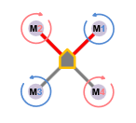
Figure 3-1.1
Hexacopters are UAV that are designed very similar to quadcopters, except that there are six blades instead of four. Like the quadcopter, each blade is attached to a motor, which is attached to an arm of the drone. There are six arms toal in a hexacopter. The main electronics are housed in the main part of the body. To keep the drone in the air, the propellers spin in different directions, as shown in figure 3-1.2. Generally, Hexacopters have the same capabilities as quadcopters, and operate in much the same way.
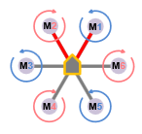
Figure 3-1.2
Fixed wing UAVs are designed very differently that quadcopters and hexacopters. Instead of blades facing the ground, they face perpendicular to the ground, like a traditional propeller airplane. Lift is not generated from the propellers, rather the wings of the aircraft. The propellers pull the plane forward. To turn, flaps on the main wings and the tail wing are adjusted. Fixed wing UAVs are not able to hover, but must circle the object they are studying if need be. Fixed wing UAVs cannot achieve vertical lift off and landings. Instead, a launchpad or runway is needed to get the UAV into the air. A runway is needed to land the plane as well.
Each drone design generally has various types of materials that they can be built out of. The most common frame materials are wood, carbon fiber, plastic, G10, and aluminum. Wood and aluminum are straightforward, and are generally available. Carbon fiber is is a tough, but lightweight material. G10 is a variation of fiberglass that can be bought in sheets
To have the drone fly in a safe manner, there are generally multiple onboard sensors and controllers. There are two main controllers on the drone, flight controller and electronic speed controllers (ESC). ESCs are circuits that take an input signal from the flight controller, and input power, and outputs a certain amount of power to the connected motor. Different models of ESCs have different input options, which can consist of pulse wave modulation (PWM), component area network (CAN), and other proprietary protocols. One example of this proprietary protocol is what DJI uses on their components, which allow for motor feedback, current draw, and voltage draw to their flight controllers. CAN is an open protocol that allows for motor feedback, current draw, and voltage draw to any flight controller that supports the protocol. PWM uses pulses to tell the motor controller what percentage to run the motor at. However, PWM does not give any feedback to the flight controller.
A flight controller is the central brain on the drone. They take in input from various sensors, communication receivers, and ESC (if supported), and sends signals to ESCs on how to run the motor. flight controllers have a range of supported sensors, protocols, and even GUI interfaces. Basic flight controllers, like the ones found in competitive drone racing or basic hobby drones, do not have a lot of onboard sensors, generally a gyroscope and accelerometer. They do have a simple GUI to tweak ESC control settings, they do not offer much more. They rely heavily on the user to control the drone, keep it steady in the air, monitor how the drone is operating. Two examples of these are the KISS FC and Lumenier LUX V2. More advanced flight controllers do have more features, such as autonomous flying, flight planning, onboard system logging, more variety of protocol support, software development kits (SDK), software simulation of hardware, gimbal support, ground station solutions, and additional onboard sensors such as inertia sensing, GPS, and barometers. Some of these flight controllers are the Pixhawk, DJI A3, and DJI N3.
With the more advanced flight controllers, there are multiple software solutions available for additional customizability. Many flight controllers, such as the Pixhawk and the LUX V2 support open source software. Other flight controllers, like the options from DJI and KISS, use proprietary software provided by the manufacture.
There are multiple communications methods that are supported by flight controllers. Examples are radio control (RC), bluetooth, WiFi and radio frequency (RF) are the most popular options. The flight controller generally does not have these modules on the controller, so a receiver/transmitter accessory needs to be purchased that will interface with the flight controller. Most controllers support most major RC and RF transmitters.
To be able to scan roads for separation, this will require the use of a thermal imaging camera. Traditionally, thermal cameras are hand held with a small screen and the ability to write the video feed to a storage device. With the rise in popularity in drones, thermal cameras are now being released in smaller form factors, which allow them to be carried by drones. One example of this is the Flir Duo. This small camera will fit in your hand, and allows you to carry it on the drone. The Duo even has a normal camera included, to allow for both thermal and regular video.
A popular method for scanning the faces of roads, buildings, and windmills is lidar. Lidar uses pulses of light to measure the distance from the sensor in a single plane. With this data, a 3D image can be created of the object. This would allow the measure of cracks length, width, and depth. Lidar systems currently are used in construction and civil applications, and are mounted on a large plane, helicopter, ground vehicle, or tripod. These lidar sensors have a range of field of view. Some can see 360 degrees around them, in a single plane. Others need to to be physically turned to reach all 360 degrees. However, with the rise in drone popularity, many lidar solutions are starting to be released in smaller form factors, and designed for drones. One example of this is the Velodyne Puck and HDL-32E.
Due to the popularity of action sport cameras, many cameras are offered with high resolution, long battery life, image stabilization, water and dust resistant, and internal video storage., With most models having existing mounting solutions, it is easy to attach these cameras to a drone. However, having a life video feed as well as storage of the video is not supported by some action sport cameras. One camera brand that does support live feed as well as storage is GoPro Hero, and Foxeer cameras
Gimbals are used to extend the range of various sensors or cameras, by allowing the connected sensor to turn on a plane. Gimbals can turn on two or three different axis, allowing for almost full coverage of the surrounding area, and image stabilization. One thing to be aware of is that if a gimbal is mounted below a drone, or on top of the drone, the drone body might block the sensor or camera from certain angles. To get full 360 degree coverage, two gimbals and two sensors/cameras will need to be used.
Once the data is collected, the data can be analyzed by open source solutions, or custom software, to bring notice to the user. Using lidar data, it is possible to identify various types of cracks and tears, and classify them for the user.
New government regulations provided by the federal aviation agency (FAA) with commercial or professional drone usage was released in 2016, which requires pilots of unmanned aerial vehicles less than 55 lbs. to have certain certifications. Pilots must be remote pilot airman certified, be 16 years or older, must keep drone below 400 feet, can only fly during the day, and fly slower than 100 mph.
While there are many drones out there for commercial usage, there are not any drones that have the ability to hold lidar, thermal, and video cameras, as well as having pre-flight planning. A drone with a single gimbal, which allows for one lidar, thermal sensor, or camera is DJI. besides providing flight controllers, DJI offers drones and gimbals. You can attach these sensors to the gimbals. Flir, the maker of thermal cameras, does offer DJI drones with their thermal cameras integrated to the drone. Phoenix Lidar Systems offers a drone with a lidar integrated in the hull. Using Phoenix software, a #D mapp of the scanned area can be created. If a 3D scan of a structure or road is desired, there are companies that offer scanning as a service, such as Infradrone. Infradrone scans and process structures or roads, and sends you the results.
There are open source option to assist in data analysis, such as Grass and BCAL LiDAR. These tools take lidar data, and create 2D and 3D images of the data. Grass markets itself as an open source geographic information system (GIS).

3.2 Proposed System Block diagram
Figure 3-2.1 shows a block diagram of the drone and control system interaction, where the lidar, camera, and thermal cameras are able to store their collected information locally on the device. Most flight controllers allow for a camera feed to transmit data through it.
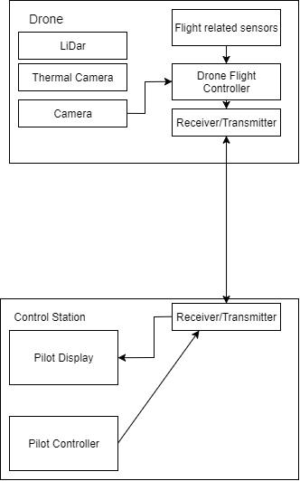
Figure 3-2.1

Figure 3-2.2 shows a block diagram if the lidar, or thermal camera cannot store the data locally on the device. It is common for lidar units to not have internal storage, so extra hardware will be needed to encode and transmit the data. The data encoder is needed because RF transmitter is generally sending data in a serial format, so the data from the thermal camera and lidar would need to be encoded, to then transmit. We would also need a decoder on the control station to decode the data, which can be used in later processing. If the camera cannot store its data locally, it can still go through the flight controller, and be captured at the control station. It would also require a storage device in the control station. If a computer is used, the internal storage device(internal hard drive, or internal SSD), or USB hard drive will suffice.
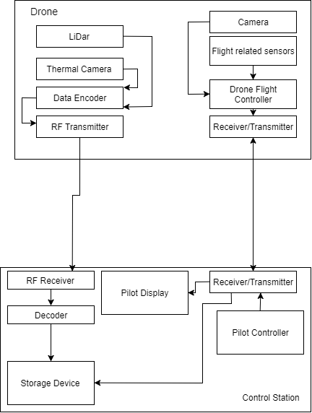
Figure 3-2.2

Figure 3-2.3 shows a revision of 3-2.2. where all data is sent through a single transmitter and receiver. This would allow for less hardware on the drone

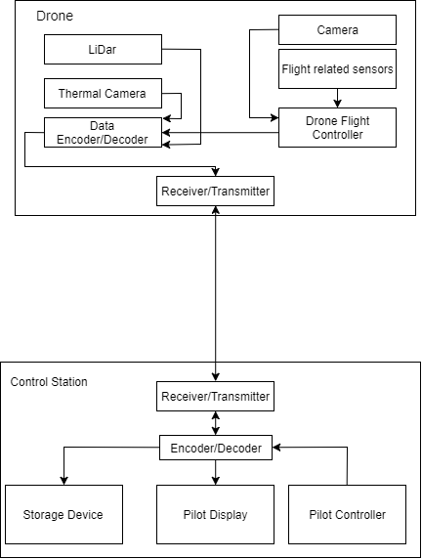
Figure 3-2.3
Below are block diagram related to drone sensors.Note that the “Data Transmission” block is just a black box representation of the various communication methods shown in above block diagrams, or the internal storage of the sensor, if applicable. Each communication method does not have an effect on the sensors and motors on the drone. The below figures would be the “Flight related sensors” and “Drone Flight Controller” blocks in the above figures.
Independent of each design, the drone will need to have a status light that will blink. The blinking light can be interpreted to allow the pilot to know what is going on with the drone if the control station is having issues. This control light is a standard feature on many flight controllers. Each design will also have a global positioning system (GPS) sensor on the drone.
Figure 3-2.4 shows the block diagram shows the drone using CAN for controlling the ESC. Note that CAN is daisy chained from one device to the next.
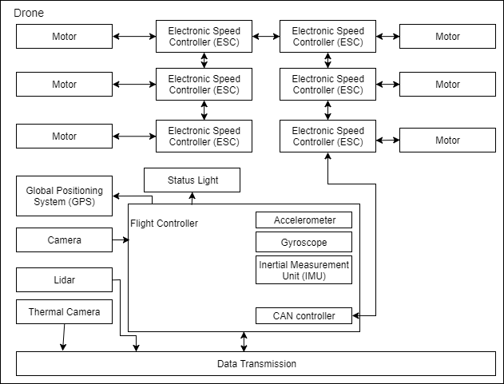
Figure 3-2.4

Figure 3-2.5 shows the block diagram using DJI’s protocol. This protocol allows for ESCs to give feedback to the flight controller, but are not daisy chained.
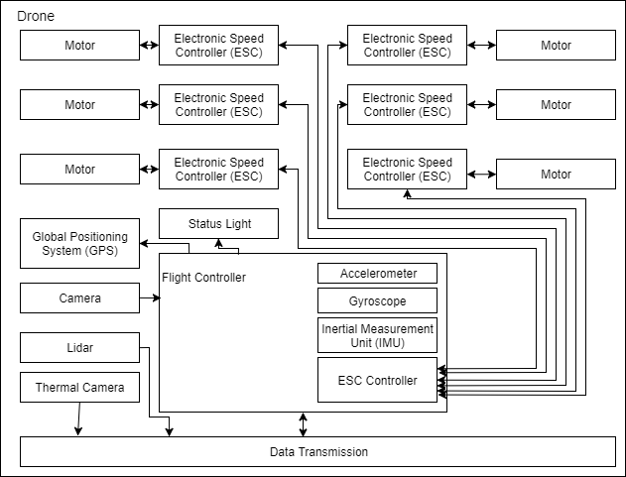
Figure 3-2.5
Figure 3-2.6 shows the block diagram using PWM. PWM data transmission requires each ESC to have its own data line. PWM does not give feedback to the flight controller.
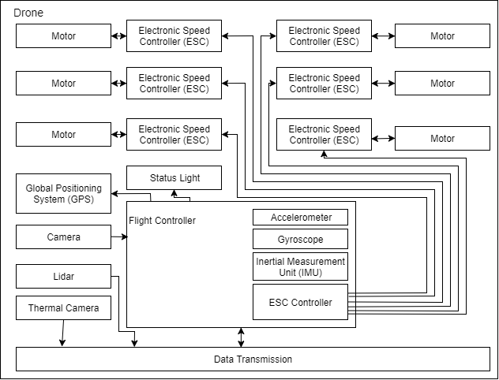
Figure 3-2.6
Once the data is captured by the drone, the data will run through data processing. During this step, it will take in the raw data, and output a couple different types of data, depending on what the user wants. The first output is 3D point cloud of lidar data, which will allow other programs to display a rotatable image that shows what was scanned. It will also allow the user to click two points, and have it calculate the measurement. This software will also classify the crack’s severity using multiple criteria that can be defined by the user. The second output is the raw lidar data, which can be processed by later programs. The third output is the raw video feed of a camera. The fourth is the raw output from the thermal sensor. Figure 3-2.7 shows this process

3.3 Assessment of Proposed methods
The first comparison that needs to be made is the different types of drones. For this project, the three main drone types that are usable for this project is a fixed wing drone, a hexacopter drone, and a quadcopter drone. Quadcopter and hexacopter drones are very similar in design, and generally the same features. Fixed wing drone have a very different set of features
There are pros and cons when looking at a quadcopter vs a hexacopter. With only needing four motors and motor controllers, quadcopters are less expensive to make, have a longer battery life, and are easier to program. However with hexacopter six motors, it can have a heavier payload, is more stable in windy conditions, and has redundancy motors if there are motor failures which allow for graceful landing. Although it takes more battery power, a hexacopter is better suited for our purpose than a quadcopter, because of its heavier payload and motor redundancy.
Hexacopters and fixed wing drones have very different set of features. A fixed wing, when compared to a hexacopter, is much more power efficient, can have larger payload, and has a much faster linear travel speed than hexacopter. However, fixed wing drones do not have the ability to hover, require takeoff and landing runways or launchers which makes taking off and landing more complicated, are harder to control when flying, and are more expensive to build. A hexacopter is easier to control by pilots, can vertically take off and land, making it a lot easier to get in the air, have the ability to hover which makes data collection easier, have more customizability, and allow for less than perfect weight distribution. For our use, a hexacopter is a better fit. Being easier to work with, easier to fly, more customizable, and the ability to hover outweigh the increased battery efficiency and payload of the fixed wing drone.
When looking at the different communication methods laid out in figures 3-2.1, 3.-2.2, and 3.-2.3, they each try to do the same thing. The main factor when selecting a design is the feasibility given the selected hardware. The dual transmitter option of 3-2.2 is the most complex option, as there are two competing signals being sent to the drone, and allow for more points of failure. 3-1.1 would be the easiest to design, but then you are limited to the small inboard storage of the various sensors. If 3-2.3 is a feasible design, that would be the design to go with. It allows the drone to send the most data, with less points of failure. One thing to consider is drones can have redundant receivers/transmitters, which would help in the event of a receiver/transmitter failure. This would be easy to implement with figure 3-2.3
With the multiple flight controller options shown in section 3.1, it would be easiest to go with the more advanced options such as the DJI controllers, or the Pixhawk. Although they are more expensive, and slightly more complex to configure out of the box than the simpler LUX V2 or KISS FC, the additional software capabilities of the more advanced options would make controlling the drone a lot easier. The autonomous flying capabilities, advanced SDKs, inertia sensing, GPS, motor feedback capability, and preflight planning are worth the extra expense. These extra feature also enhance the predictability and safety of the camera, thermal sensor, and lidar sensors.

3.4 Validation
How will you confirm that your solutions work?
To verify that the UAS system is properly working, and meets product deliverables, the following test cases are defined.
- Have the drone fly with a weight if 55lbs
  - Test steps
    - With required software and hardware for the drone to be usable and human controlled, , attach extra weight securely to the drone so drone is 55 lbs
    - Conduct vertical takeoff procedure
    - Hover drone for 5 minutes
    - Bank drone bank left
    - Bank drone bank right
    - Have drone fly forward
    - Have drone fly backward
    - Turn drone counterclockwise 180 degrees
    - turn drone clockwise 180 degrees
    - Conduct vertical landing procedure
  - Goal of testing
    - With the maximum load allowed by FAA regulations, have the drone be able to be flown and easily controlled
  - Defined success:
    - Drone is able to safely and smoothly take off vertically
    - Drone is able to hover in the same spot for 5 minutes
    - Drone is able to bank left and right
    - Drone is able to fly forward and backward
    - Drone is able to turn 180 degrees in both directions
    - Drone is able to safely land without damage to the drone
    - Drone flies in a predictable manner by the pilot
- Flight Time
  - Test steps
    - With required software and hardware for the drone to be usable and human controlled, , attach extra weight securely to the drone so drone is 55 lbs
    - Conduct vertical takeoff procedure
    - Hover for 40 minutes, or until critically low battery percentage
    - Conduct landing procedure
  - Goal of testing
    - With maximum allowed weight, the drone should have a 40 minutes best case flight time.
  - Defined success
    - Drone is able to hover for 40 minutes
    - Drone is able to safely land after hovering
- Windy Conditions
  - Test steps
    - Find conditions with 20-30 mph sustained winds. Gusts above 20-30 are okay
    - With required software and hardware for the drone to be usable and human controlled, , attach extra weight securely to the drone so drone is 55 lbs
    - Conduct vertical takeoff procedure
    - Hover drone for 5 minutes
    - Bank drone bank left
    - Bank drone bank right
    - Have drone fly forward
    - Have drone fly backward
    - Turn drone counterclockwise 180 degrees
    - turn drone clockwise 180 degrees
    - Conduct vertical landing procedure
  - Goal of testing
    - The state of Iowa can be very windy at times. The drone still wants to be flown in these windy conditions.
  - Defined success
    - Drone is able to safely and smoothly take off vertically
    - Drone is able to hover in the same spot for 5 minutes
    - Drone is able to bank left and right
    - Drone is able to fly forward and backward
    - Drone is able to turn 180 degrees in both directions
    - Drone is able to safely land without damage to the drone
    - Drone flies in a predictable manner by the pilot
- Sensing
  - Test steps
    - Attach camera, thermal sensor, and lidar units to drone
    - Conduct vertical takeoff procedure
    - Select object to scan
    - Scan selected object with all three sensors
    - Conduct landing procedure
  - Goal of testing
    - To verify that each sensor works properly, and data that is generated is captured
  - Defined success
    - Data from each sensor is captured in a way that can be processed at a later time
- 360 degree coverage
  - Test steps
    - Attach camera to drone
    - Conduct vertical takeoff procedure
    - Start video recording
    - Conduct procedures to video record 360 degrees around the drone, with the drone hovering in one spot, and is not turning
    - Conduct vertical landing procedure
  - Goal of testing
    - Have the drone be able to record every angle around it, without the need to run the drone
  - Defined success
    - Video recording(s) shows all angles around the drone
- Sensor Swap
  - Test steps
    - Attach video camera to gimbal
    - Conduct vertical takeoff procedure
    - Start video recording
    - Record for 1 minute
    - Stop video recording
    - Conduct vertical landing procedure
    - Take video camera off of gimbal
    - Attach thermal sensor to gimbal
    - Conduct vertical takeoff procedure
    - Start thermal sensing
    - Record for 1 minute
    - Stop thermal sensing
    - Conduct vertical landing procedure
    - Take thermal camera off of gimbal
    - Attach lidar to gimbal
    - Conduct vertical takeoff procedure
    - Start lidar sensing
    - Record lidar data for 1 minute
    - Stop recording lidar data
    - Conduct vertical landing procedure
  - Goal of testing
    - Verify that all sensors can attach to the drone’s gimbal
    - Verify that all sensors can properly recorded data, and be captured that allow for later data processing
    - Verify that all sensors can be used without major software reconfiguration
  - Defined success
    - All sensors can attach to the drone’s gimbal
    - All sensors can interface with drone electronics
    - All sensors can record without the need for major software configuration between sensor switches
- Communication stress
  - Test steps
    - Set up drone transmitter(s)/receiver(s)
    - Set up control station transmitters) and receiver(s)
    - Connect to a microcontroller that is able to emulate data to be transmitted, and can receive data
    - Move transmitters and receivers 100 feet from each other, but can maintain line of sight
    - Using the microcontroller, send as much data at the max transfer rate for 5 minutes
  - Goal of testing
    - Under max transferring rate, make sure the communication system can maintain communication
  - Defined success
    - Communication is maintained, and the data is that was sent is the same data that was received on the other end
- User Controllable
  - Test steps
    - With required software and hardware for the drone to be usable and human controlled, , attach extra weight securely to the drone so drone is 55 lbs
    - Conduct vertical takeoff procedure
    - Hover drone for 5 minutes
    - For 30 minutes, let the pilot fly around, raising, lower, banking, flying forward, and backward as the pilot feels.
    - Conduct vertical landing procedures
  - Goal of testing
    - Pilot feels comfortable controlling the drone
  - Defined success
    - When conducting the test steps, pilot maintains complete control, and drone flies as the pilot predicts it should based off of the input from the pilot.
- Motor Feedback
  - Test steps
    - Have drone in production hardware configuration
    - Conduct vertical takeoff procedure
    - Hover for 5 minutes
    - During hovering, observe motor current draw, voltage draw, and RPM.
    - Conduct vertical landing procedures
  - Goal of testing
    - Verify motor health can be monitored while drone is flying
  - Defined success
    - motor current draw, voltage draw, and RPM viewed in real time
- FAA requirements
  - Test steps
    - Locate FAA drone requirements for commercial use
    - Verify drone follows all requirements
  - Goal of testing
    - Drone is FAA compliant for flying
  - Defined success
    - Drone passes all FAA requirements
- FCC requirements
  - Test steps
    - Locate FCC rone requirements for commercial use
    - Verify drone follows all requirements
  - Goal of testing
    - Drone is FCC compliant for flying
  - Defined success
    - Drone passes all FCC requirements
- Data Analysis human readable output
  - Test steps
    - Locate already captured data from the drone
    - Run data through data analysis programs Run data through data analysis so output is in a raw, human readable format
    - Open output
    - Have human analyze the data
  - Goal of testing
    - Data from the drone can be read by a human
  - Defined success
    - Human can analyze data
- Data Analysis computer assisted output
  - Test steps
    - Locate already captured data from the drone
    - Run data through data analysis so output is in a computer assisted human readable format
    - Open output
    - Have human analyze the data
  - Goal of testing
    - Output from this part of the data analysis makes sense to a human
  - Defined success
    - Output from this part of the data analysis makes sense to a human
- Communication failure
  - Test steps
    - Have drone in production hardware configuration
    - Conduct vertical takeoff procedure
    - Hover for 5 minutes
    - Turn off communication on the driver station
    - Observe results
  - Goal of testing
    - In the event of a communication failure, drone will safely land
  - Defined success
    - After 5 minutes, or critical battery level (whichever is first), the drone will land itself
    - In the time before the drone lands, the drone hovers in the same spot
- Motor Failure
  - Test steps
    - Have drone in production hardware configuration, with the additional ability to have motor loose connection to the system
    - Conduct vertical takeoff procedure
    - Hover for 5 minutes
    - Remotely cut off one motor from the drone system
    - Hover for 1 minute
    - Conduct vertical landing procedure
  - Goal of testing
    - In the event of a motor failure, the drone be able to recover ,and safely land
  - Defined success
    - Drone is able to hover for 1 minute when a motor has failed
    - Drone is able to land with one failed motor

4 Project Requirements/Specifications

4.1 Functional
List and explain the functional requirements of the project. This would include all the technical requirements you fulfil during your senior design project.
Our functional requirements overlap with most of our goals. This is due to the nature of our project, which is creating a tool for data collection and analysis.

4.1.1 Drone
- 40 minute flight time
- be able to withstand 20-30 mph winds
- modular design
  - sensors
  - drone parts
- camera on gimbel so it can capture the undersides of bridges
- ability to program flight plans

4.1.2 Control System
The control system will need to be able to:
- Control the drone
- Monitor drone health
- Store Data

4.1.3 Image and Data Processing
- Analyze cracks and other faults by their:
  - width
  - depth
  - length
  - severity
  - location
- Ability to create topographic map from sensor and camera data

4.2 Non-functional
List and explain the non-functional requirements of the project. This is where you would enlist non-technical requirements. This may still be a fundamental deliverable that your client needs at the end of the semester.

4.2.1 Cost
We have a budget for the drone and sensors of between $3,000 and $5,000. This funding is provided by our client through his own research funding so it is important to spend it wisely.

4.2.3 Reliability
Because this drone will be fairly expensive to build, we need it to be reliable during flight so as not to crash. The drone will need to have consistent performance while in the air both in data collection and actual flight. We will need it to continuously communicate with the control station so we know if it needs to be brought down. As mentioned in the Functional Requirements, the drone will have to be reliable in 20-30 mph winds and for flight times up to 40 minutes.

4.2.4 Reusability & Maintainability
This drone and system will need to be used after the student team has graduated. Therefore, the parts should be durable and cheap but easy to replace if they do break. This means we will elect to purchase off the shelf components as opposed to creating custom components when possible. In the case of the gimbal, which we will likely need to 3D print, or other necessary custom parts, we will make sure to clearly document how to recreate the part.

4.2.5 Certifications
Each member will become certified to fly the drone. (subject to change)

4.3 Standards
Discuss the standard protocols that you follow in your lab or for writing code. Are these approved by standard organizations like IEEE, ABET etc. Will any of your practices be considered unethical by such organizations? Discuss how standards are applicable to your project.

4.3.1 FAA
Our drone will fall in the category Fly for Fun under the Special Rule for Model Aircraft. We will elect to register our drone in case it gets lost. The following requirements will be followed, as specified by the Special Rule for Model Aircraft:
- Fly at or below 400 feet
- Be aware of airspace requirements and restrictions
- Stay away from surrounding obstacles
- Keep your UAS within sight
- Never fly near other aircraft, especially near airports
- Never fly over groups of people
- Never fly over stadiums or sports events
- Never fly near emergency response efforts such as fires
- Never fly under the influence of drugs or alcohol

5 Challenges
Include any concerns or details that may slow or hinder your plan as it is now. These may include anything to do with costs, materials, equipment, knowledge of area, accuracy issues, etc.
The biggest concern for our team is the possibility of crashing the drone. If we happened to crash the drone we would experience a major setback in our project. The cost of rebuilding a drone and the possible cost of replacing any broken sensors from a crash would be in the thousands of dollars. Not to mention the time that would be wasted rebuilding the drone and ordering replacement parts and sensors which can take weeks to months to arrive. It is definitely an outcome that our team wants to avoid at all costs. To help mitigate this, we need to be very careful that our design for the drone has no flaws and that the load it carries is balanced to help stability of the drone’s flight. In addition, everyone on our team who will be flying the drone will be FAA drone pilot certified. This involves taking a practical and written test about how to fly a drone and relevant safety protocols involved. This will also be another challenge since in order to fly the drone legally, the pilot must pass this test. Studying and practicing for the FAA pilot certification test will also take time to accomplish, and must be done before we can start testing our project.
In addition to learning drone flight protocols, our team will also have to expand our knowledge about data collection and processing relating to infrastructure and drones. Will we need to learn about thermal sensors, LIDAR sensors, and visual cameras specs. Information such as stabilizing on a moving drone, distance from which the sensors are effective, and how accurate the readings of the sensor can be in various weather conditions are all factors that will need to be taken into account. Then once we have collected the data, we will need to have knowledge over how to process the raw information into useful statistics and data. This process may be simplified significantly by implementing pre-existing open source softwares. Our team will then need to coordinate with the client and the client’s provided resources in order to gain understanding on what processed data is relevant to the infrastructure health and should be highlighted in our data processing software.
The major challenges faced by our team have the potential to create large, significant, time delays. However, as long as we remain vigilant and start preparations to avoid these pitfalls now as we already have, our plan should be able to run smoothly without a hiccup.

6 Timeline
You may want to include a Gantt chart/something similar to help visualize your timeline to complete the project.
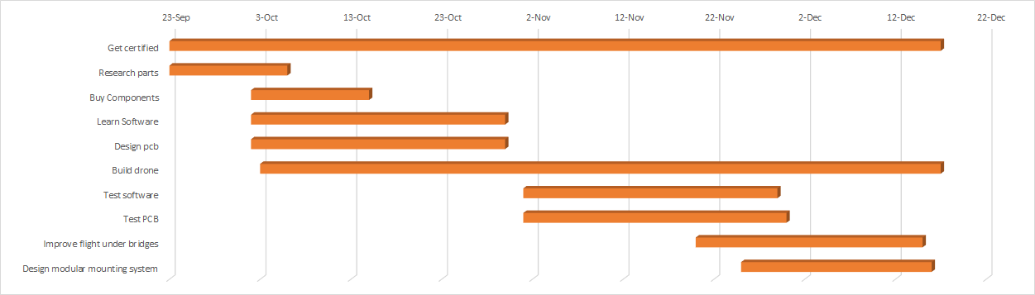

6.1 First Semester
Breakdown your timeline into detail of what needs to be done by the end of the first semester. You may want to include division of work amongst the team.
The group will be split into a hardware team and a software team.
First week will consist of each team researching parts and coming to a conclusion on what components to buy. This would include, sensors, frame, battery, gimbal, motors, and many others. After the parts have finalized and ordered, our time will be next spent learning the software necessary to use the components, and the hardware limitations to power the components. Many sensors has their own proprietary software, therefore the software team will spend the next few weeks trying to learning it. The hardware team will be looking at the components’ datasheets to design a PCB that will power the components such as motors, and sensors. As parts arrive, we will continuously build and add to the drone. This way we have a clear representation on any mechanical issue that may occur throughout the project.
After the majority of the hardware or software aspects are finished, a team will begin designing a modular system for attaching sensors and battery to the drone.
Some time during the semester, we will need to get certified to fly a drone. This will be essential for flight tests. A full day, when we are all available, will be spent driving to a facility to complete all the necessary paperwork, fees, and training to legally fly a drone.
The end goal for the first semester consist of functional individuals parts. These parts may or may not work together by the end of the semester.

6.2 Second Semester
Detail what needs to be done in the second semester. You may want to include division of work amongst the team.?
What is needed to get done next semester mainly depends on how much progress we made during the first semester. Assuming we reached our desired end goal for the the first semester, we would need to spend the 2nd half of the school year integrating the various components together and running tests. This would include attaching sensors to the hexacopter in a modular fashion, adjusting the sensor to take accurate data while on the UAV, optimizing battery usage, testing flight under rigorous conditions, and many others. Majority of the time spent will be due to testing, calibrating, and troubleshooting errors.
The group will be split into 2 teams: hardware, and software. The software team will be in charge of overseeing the use of sensors. This includes the calibration of the sensors with the drone, and the data collection tests. The hardware group will be improving the controls(flight pattern), optimizing battery, and verifying modular capabilities.
In the end, we will have a fully functioning hexacopter that has flight time of at least 40 mins, capability to fly undér bridges, and ability to collect data from sensors.

7 Conclusions
Our goal with this project is to design and build an unmanned aerial vehicle with the capability to scan infrastructure using a group of sensors, including thermal, lidar, and optical video cameras. The data gathered during these scans will then be used to detect faults and stresses which otherwise may go undetected.
Quite a lot of preparation, planning, and persistence will need to be put towards this project if we want to ensure that all of our goals are met. The largest of these goals are as follows:
- Build a hexacopter with a modular design so parts can be switched easily
- Achieve a flight time of at least 40 minutes so a sufficient amount of data is collected
- Analyze raw data to detect infrastructure faults
- Work as a team to create an efficient and positive group environment
As a team, we have taken the necessary steps (outlined above) to ensure that our project meets all the requirements put forth by our client, instructor, and ourselves.

8 References
List all the sources you used in understanding your project statement, defining your goals and your system design. This report will help you collect all the useful sources together so you can go back and use them when you need them.
Damien. Frame Type #1 Quadcopter How to Build a Drone - A Definitive Guide For Newbies. Electronic. http://beginnerflyer.com/wp-content/uploads/2015/08/rsz_multi_rotor_configs.png Accessed 24 Sept. 2017
Damien. Frame Type #3 Hexacopter How to Build a Drone - A Definitive Guide For Newbies. Electronic. http://beginnerflyer.com/wp-content/uploads/2015/08/rsz_1multi_rotor_configs.pn
Damien. How to Build a Drone - A Definitive Guide For Newbies. beginnerflyer.com/build-a-drone/. Accessed 24 Sept. 2017
“Lidar.” Wikipedia, Wikimedia Foundation, 22 Sept. 2017, en.wikipedia.org/wiki/Lidar. Accessed 24 Sept. 2017.

9 Appendices
If you have any large graphs, tables, or similar that does not directly pertain to the problem but helps support it, include that here. You may also include your Gantt chart over here.

